**Level Obstacle Sequences: Rewards**

The game is a shoot ‘Em Up type of game but without the mechanics of shooting. The levels would be filled with enemies and turrets that will try and shoot down the main character. Although the objective of the game is to reflect and dodge incoming projectiles from these assets, implementing sequences where the character can sneak around would give a different approach to this concept.

**These sequences would not be present the whole game but would only be available for the players if they choose to collect rewards. Tackling such obstacles would allow the players to receive an award in return. These mechanics would be some of the trigger for the players to distinguish the normal levels to reward levels.**

**Sneak**- This instance would require enemies to have radius points to which can only be triggered by the main character. Enemies would be programmed to patrol to certain location where they are unable to see the character. As the character is unable to attack, the only way of progressing from these instances would be to sneak around them.

**Spotlights**- The character is required to hide from the blind spots along the levels to hide from enemies. These enemies will be in idle mode and unable to see the character. The spotlight would be hovering from point A to point B but would be given out some weak areas where the players can hide from. Some enemies would also implement this kind of concept by holding a torch for each. This would allow the players to differentiate the enemies from another.

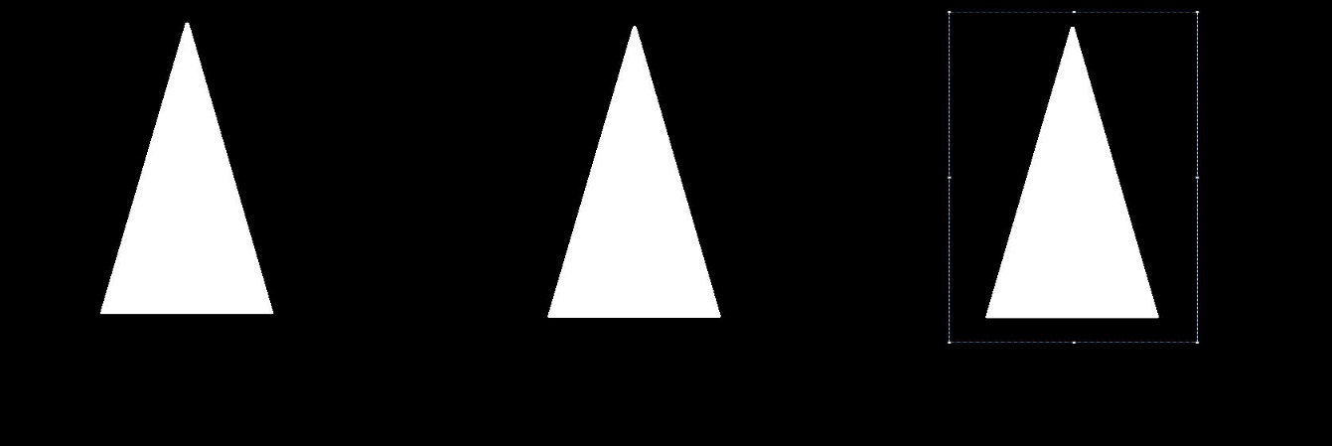

**Lasers**- Once a laser catches your position, it would take a certain time to be able to shoot. This would allow the players to back off and hide or run towards a safe area.

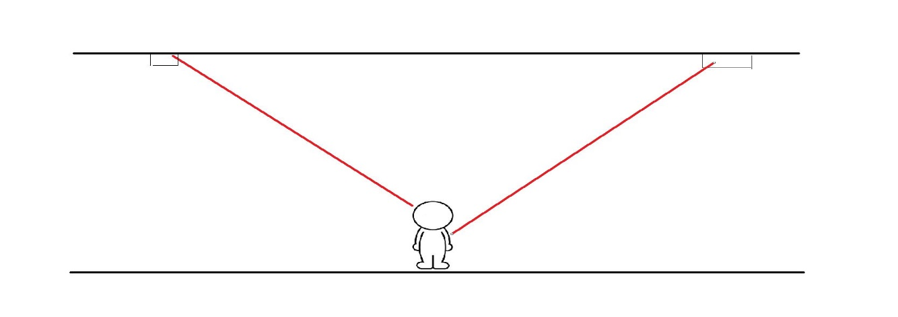

**Character Input Key Mechanics (PC or Console Controller)**

**Slide**- property where the character would be allowed and required to use such action. Platforms would be designed to corporate this action to escape or use as an attack by sliding towards the enemies.

**Double Jump** - This movement can be used to jump along ledges with the use of the shield incorporated with the main character. For this action to be used, dragging down the mouse cursor would allow the shield to position itself in the direction of the chosen jumping area.

**Mouse cursor/ Controller right-analog** – This would allow the players to point and direct the shield towards enemy projectiles. This input can also be used to navigate along the platform.

* **Jumping and dragging down cursor/analog** – would allow the character to sprint/slide for a certain amount of time. By using the shield to slide along the platform, this would allow the players to escape or sprint from the enemies or traps.

**WASD Keys/ Controller left-analog**- character movements.

**Shift key/tapping ‘X’ overtime** - property where the players would be able to sprint along the platform to get to a position where they could be safe from enemy projectiles.